Exercises: Unit Testing Arrays
Submit your solutions here: https://judge.softuni.org/Contests/5198/Unit-Testing-Arrays-Exercise

Unit Test Array: Reverser
Test a given method which takes in an array of strings and reverses each string in the array.
The method is found in the Reverser.cs file:
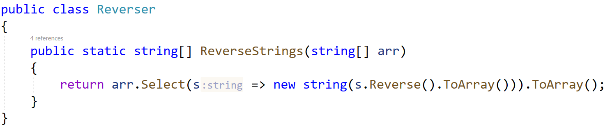
In the test file ReverserTests.cs you are given 1 finished test, 1 partially finished test, and 2 empty tests. Finish them and run them:
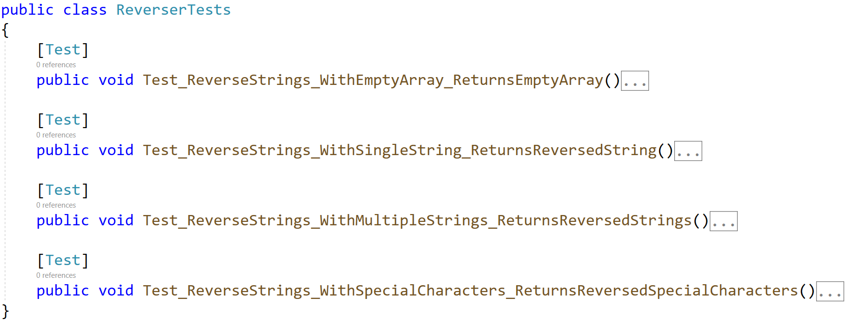
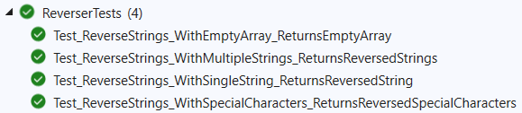

Unit Test Array: Duplicates
Test a given method which takes in an array of integers and removes all duplicate numbers.
The method is found in the Duplicates.cs file:
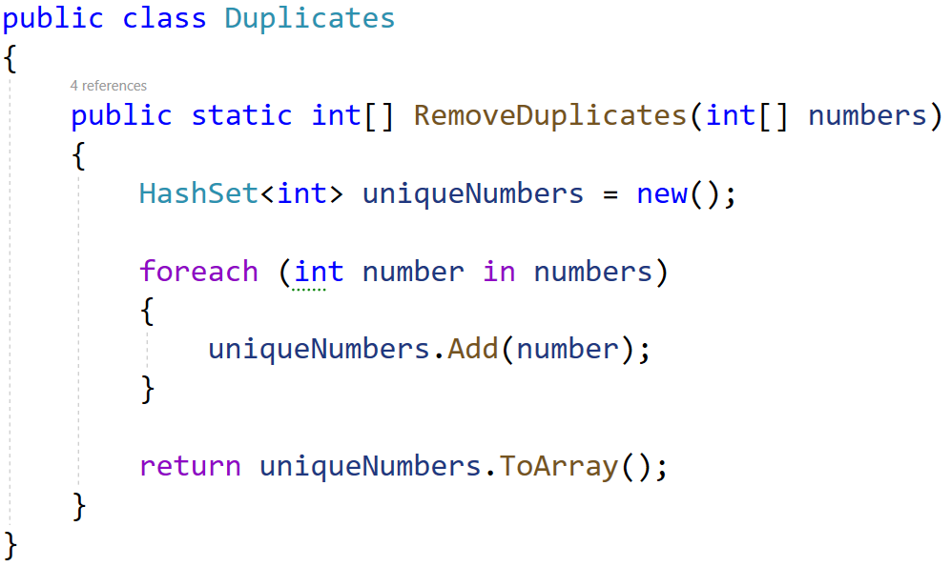
In the test file DuplicatesTests.cs you are given 2 partially finished test, and 2 empty tests. Finish them and run them:
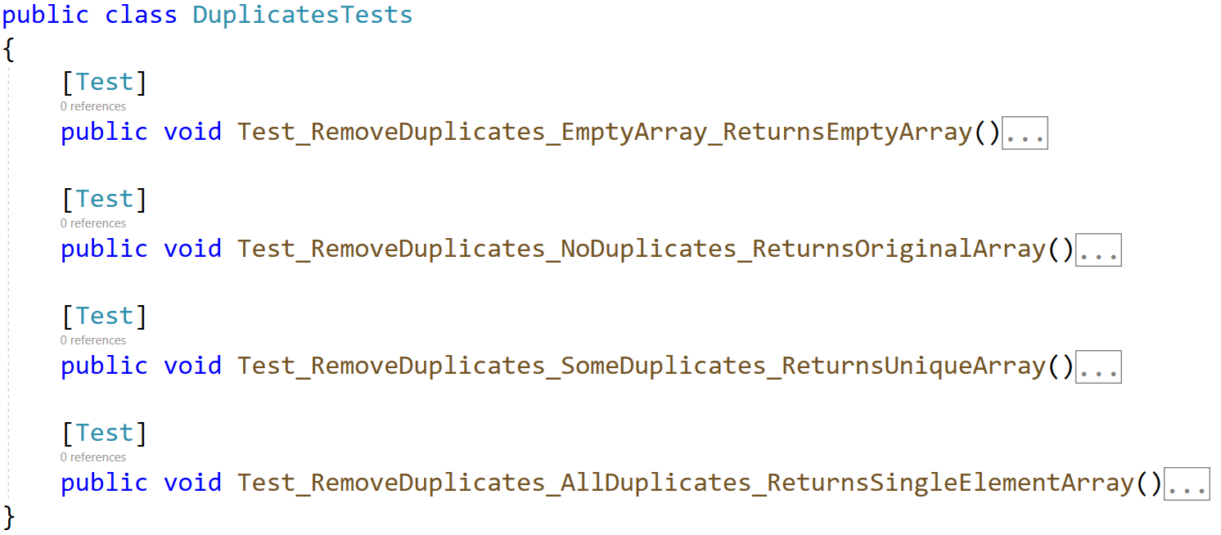
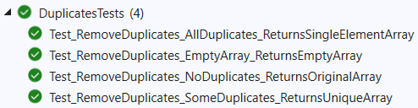

Unit Test Array: Fake
Test a given method which takes in an array of characters and removes all characters which are numbers and not letters.
The method is found in the Fake.cs file:
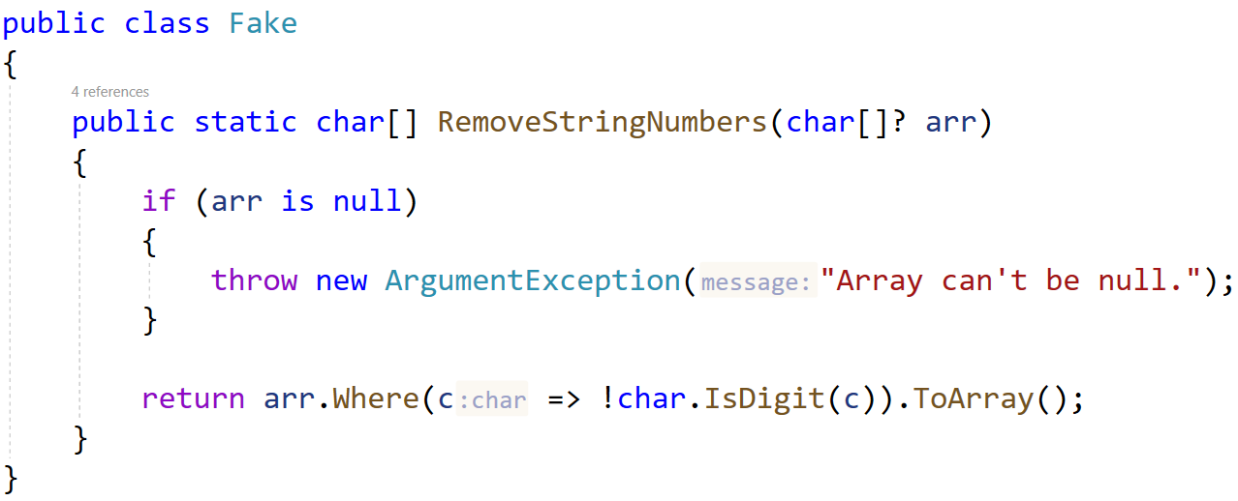
Notice the method throws ArgumentException if the array is null.
In the test file FakeTests.cs you are given 3 empty tests:
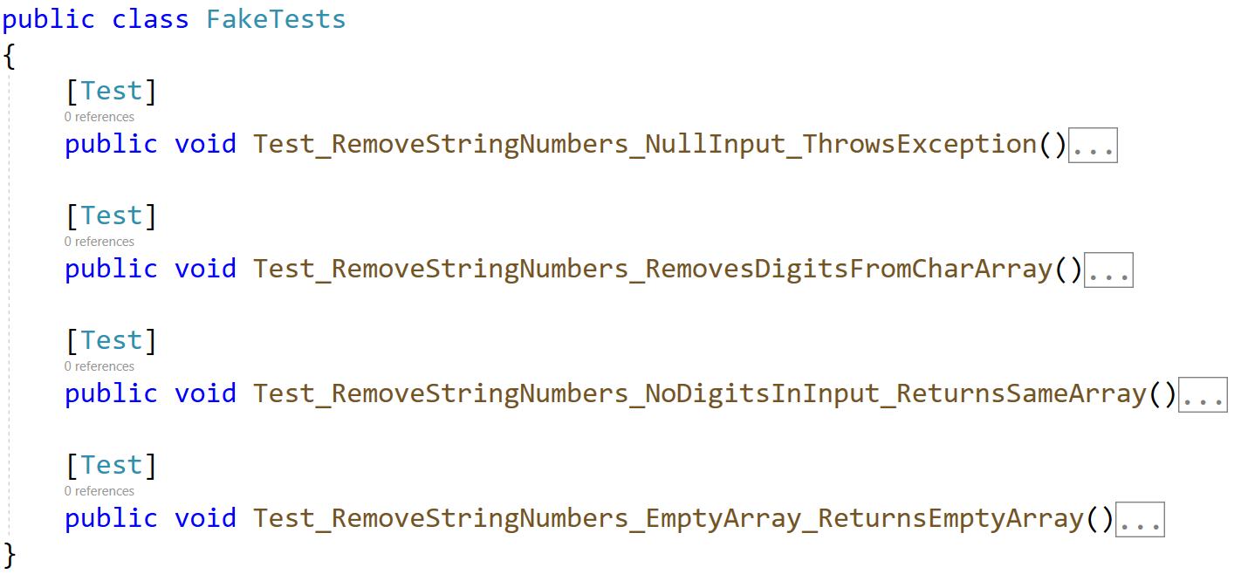

Unit Test Array: Pattern
Test a given method which takes in an array of integers that removes all duplicates and sorts the list in a zig-zag pattern.
Example: If we have an array 1 2 1 3 4 10 12 15 the sorted array would be: 1 15 2 12 3 10 4.
The method is found in the Pattern.cs file:
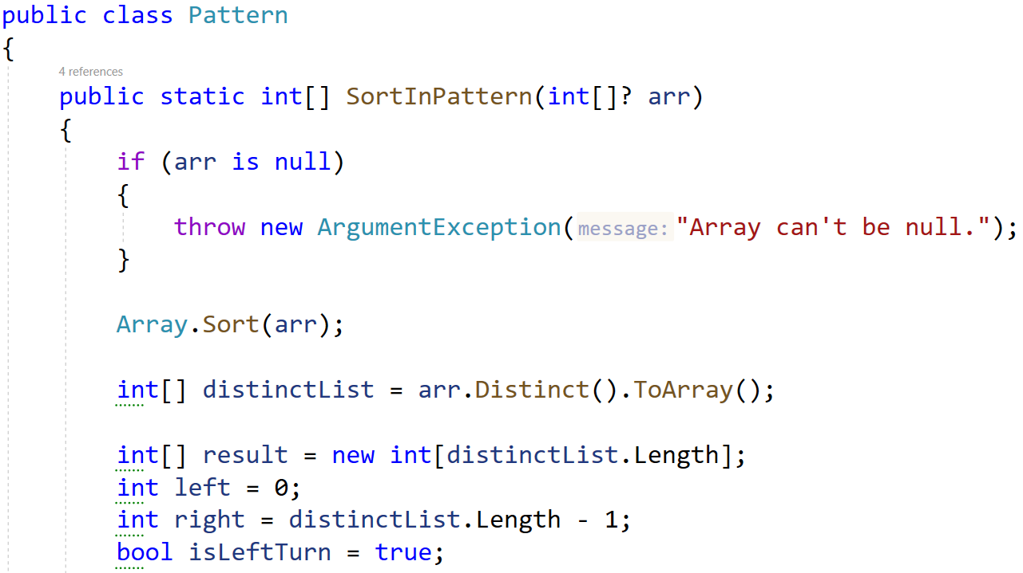
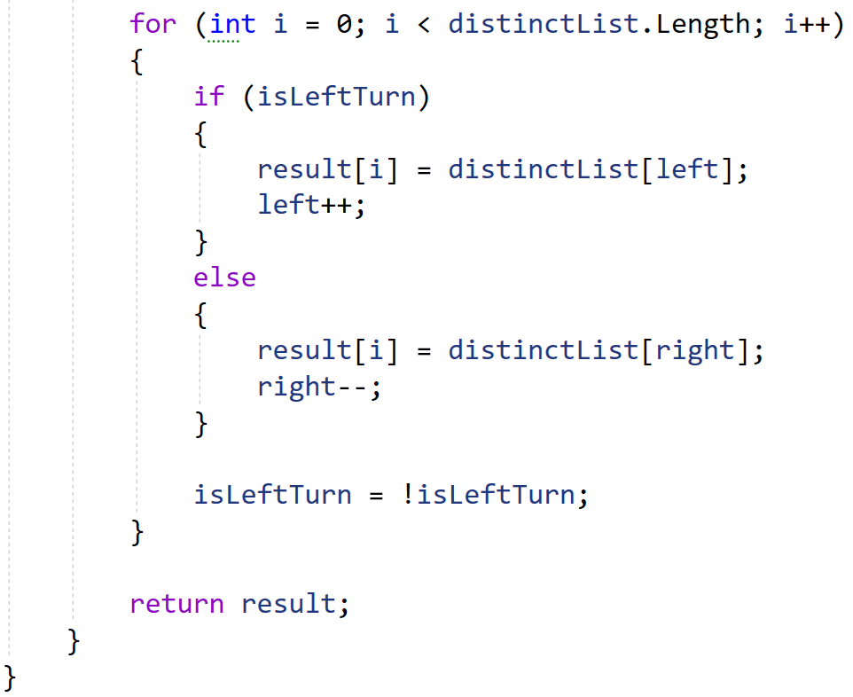
In the test file PatternTests.cs you are given tests:
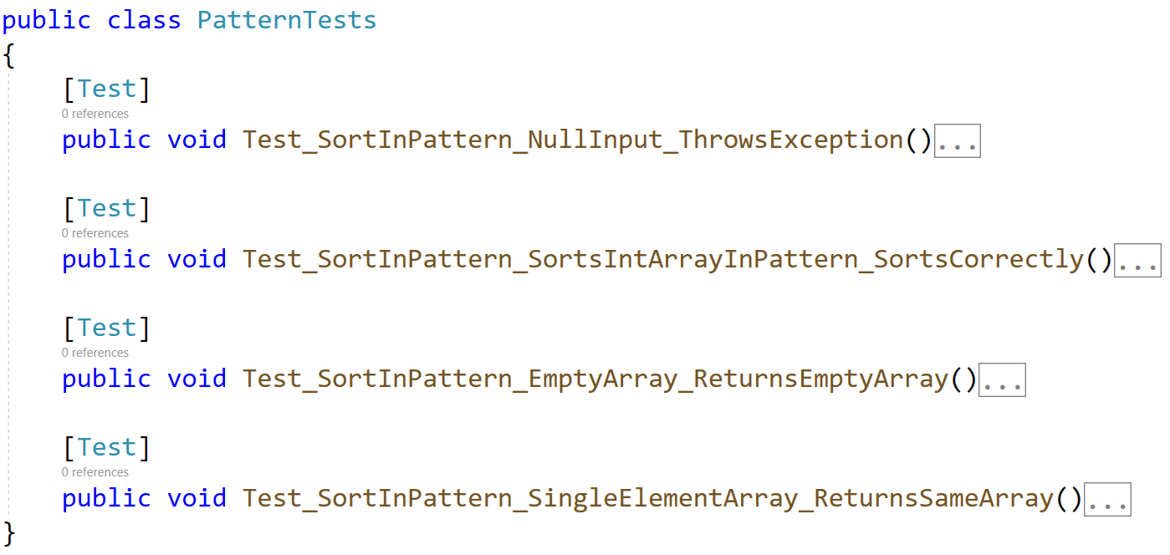

Unit Test Array: Top Integer
Test a method that takes in an array of integers and returns string of top integers, separated by single space. A top integer is an integer that is greater than all the elements to its right.
Note: The method is not static. You need to call it in a different way.

Examples
Input | Output
4 3 2 | 4 3 2
10 | 10
14 24 3 19 15 17 | 24 19 17

The method is found in the TopIntegers.cs file:
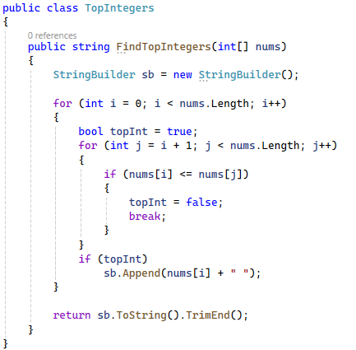
You are given a test file TopIntegersTests.cs containing 4 empty tests:
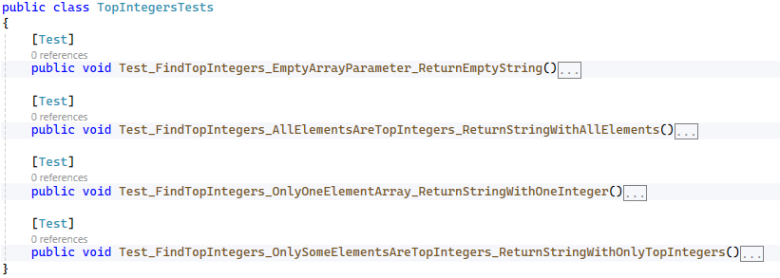
When you are ready make sure your tests run:
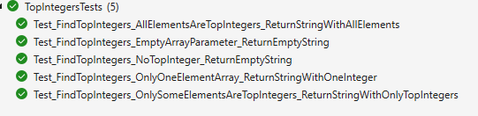

Unit Test Array: Majority
Test a method that takes in an array of integers and returns:
- Positive integer, if even numbers are majority.
- Negative integer, if odd numbers are majority.
- Zero if even and odd numbers are equal.
The method is found in the Majority.cs file:
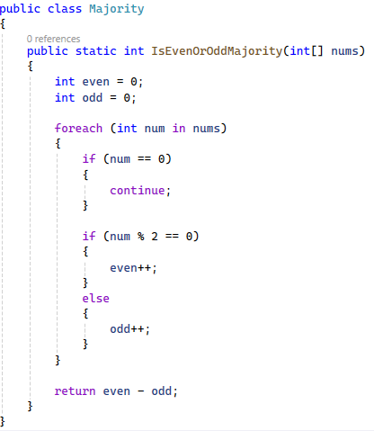
You are given a test file MajorityTests.cs containing 5 empty tests:
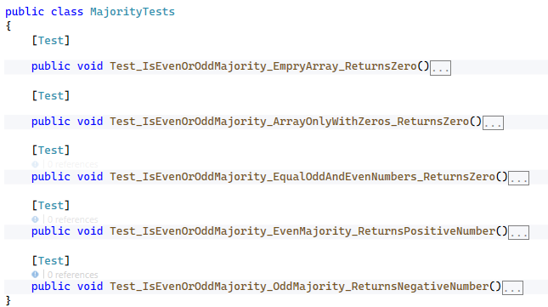
When you are ready make sure your tests run:
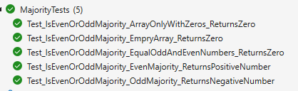

Unit Test Array: First Repeating Element
Test a method that takes in an array of integers and returns the first element that repeats. If no repeating elements are found, return -1.
The method is found in the RepeatingChecker.cs file:
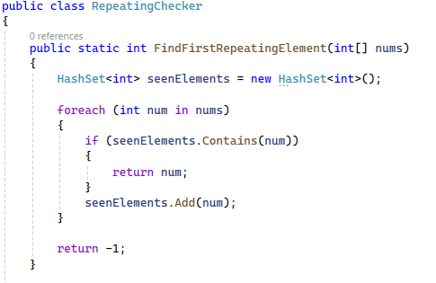
You are given a test file RepeatingChecker_FirstReapeatingElementTests.cs containing 6 empty tests:
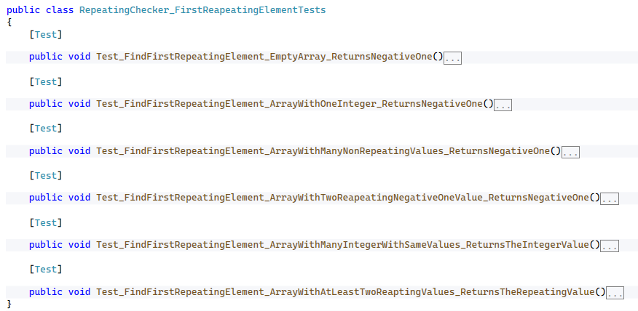
When you are ready make sure your tests run:
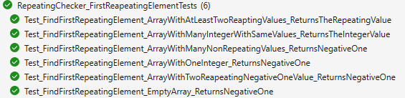

Unit Test Array: Last Repeating Element
Test a method that takes in an array of integers and returns the last element that repeats. If no repeating elements are found, return -1.
The method is found in the RepeatingChecker.cs file:
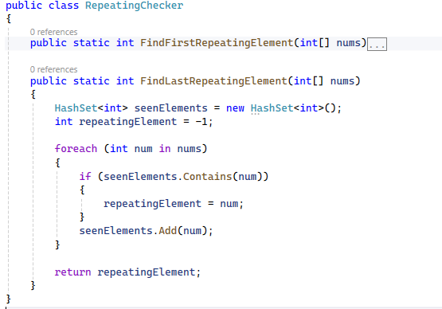
You are given a test file RepeatingChecker_LastReapeatingElementTests.cs containing 6 empty tests:
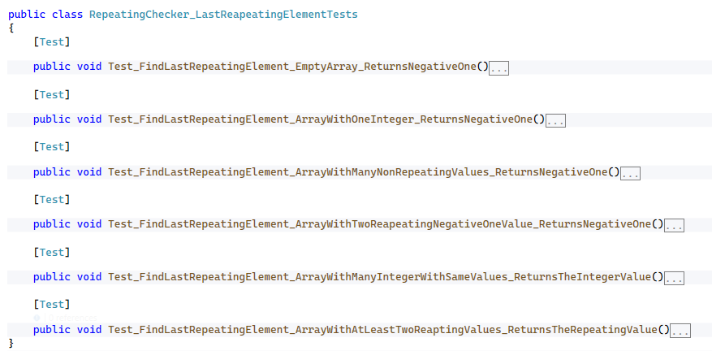
When you are ready make sure your tests run:
